Project Post-mortem

Industry Web Project

# **Project Description**

*This project was to design and create a site for the club HPCC or Handheld and Portable Computer Club. The client was the club or more specifically Mark Power. The team members were primarily Jorden Barker and for the first weeks of the project Darryl frost.*

# **Key Accomplishments**

*During the project the development after the split in the group it went well and a lot of progress was made, I used the methodology Scrum which was better as I was able to focus on it for weeks at a time then have a break. WordPress was very useful and cut a lot of development and was shortened due to it.*

# **Key Problem Areas**

*At the start of the semester not a lot of progress was made and didn’t work well with the methodology. The main problem during the project was the group, before we split we tried to work together but not much progress would be made, also a challenge I faced was learning how to use WordPress.*

# **Future Consideration**

*There is a lot of room for future development, depending on what the client wants, but this would include a more flushed out home page which could include more information the club with a membership form and some more information , I would also get rid of the news page as there is news on the other pages so it would be useless, the only page that for the task was not completed was the magazines page as I wasn’t able to figure out how to work it using WordPress. A small amount of client training is needed to be able to modify the site using WordPress.*

# **Evidence of individual contribution**

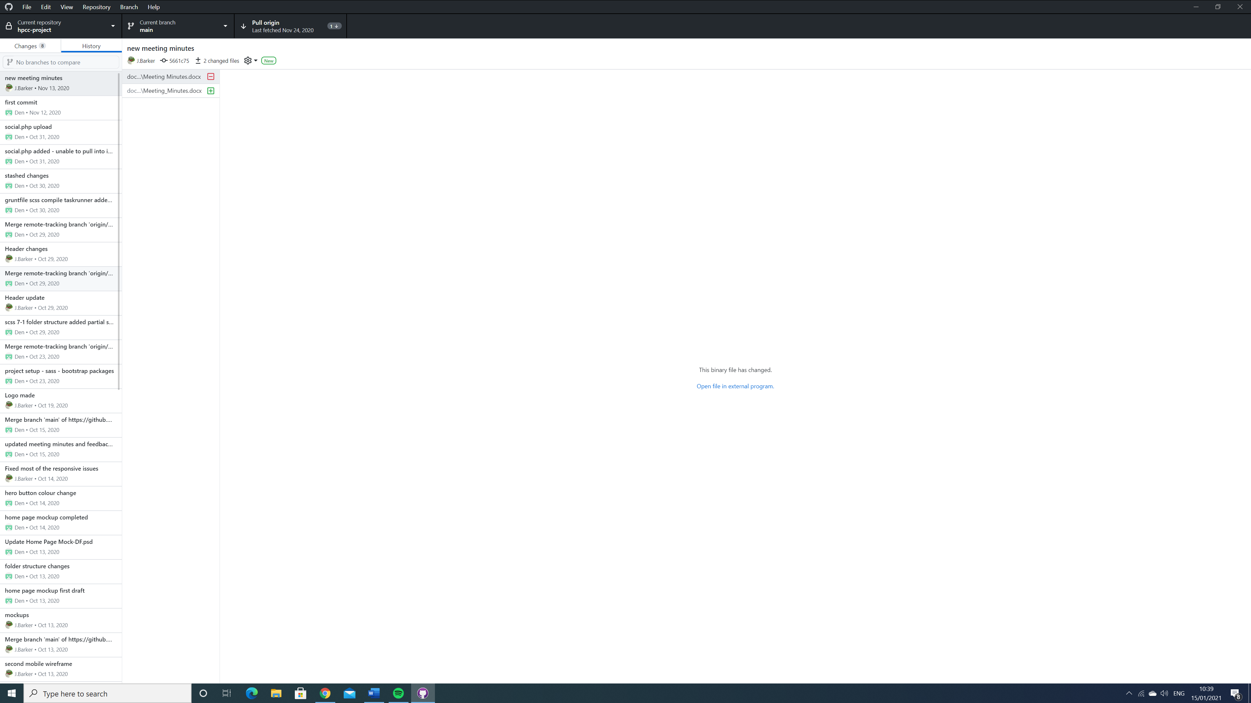

*Throughout the project especially at the start I would upload my work to GitHub which was used by both myself and Darryl, I then when on to make my own GitHub, we also used a Trello board which again we both used and would use it to give each other tasks, then I made my own which I used to give myself tasks which would last a week or two. Also, at the start of the project the group would communicate over slack and would plan meetings.*

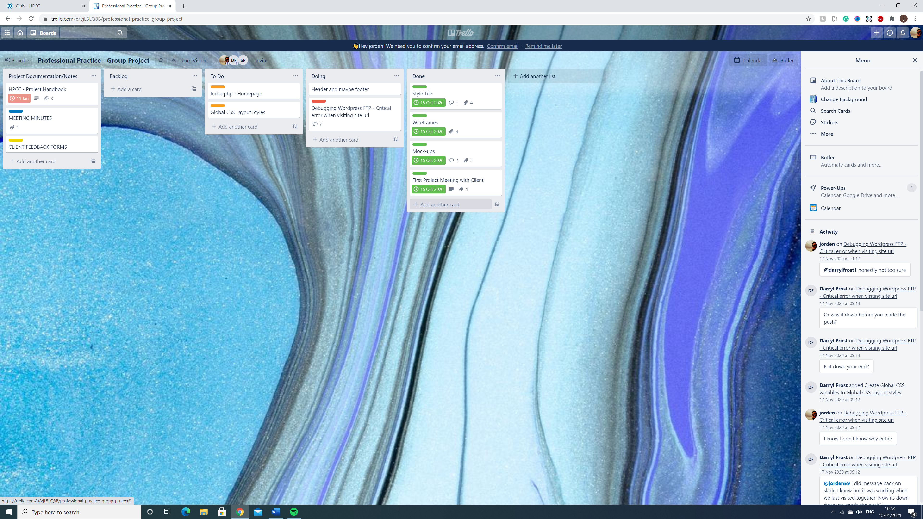

# **Individual Record of Meetings/Presentations Attended**

*[Keep a record of what meetings you personally attended]*

|  |  |  |
| --- | --- | --- |
| **Date / Time** | **Location** | **Meeting Purpose** |
| *11/10/2020 12:40* | *Online* | *Weekly team meeting* |
| *15/10/2020 9:30* | *Online* | *Client meeting* |
| *18/10/2020 12:05* | *Atrium (A2.12)* | *Weekly team meeting* |
| 25/10/2020 | On my computer | Weekly meeting |
| 1/11/2020 | On my computer | Weekly meeting |
| 12/11/2020 | Online | Client meeting |
| 24/11/2020 | On my Computer | Weekly meeting |
| 5/12/2020 | On my computer | Weekly meeting |
| 17/12/2020 9:30 | Online | Client meeting |
| 22/12/2020 | On my Computer | Weekly meeting |
| 14/1/2021 | Online | Final submission |

# **Post-Mortem Survey**

1. The project team worked effectively together.

|  |  |  |  |  |  |  |  |  |  |  |  |
| --- | --- | --- | --- | --- | --- | --- | --- | --- | --- | --- | --- |
|  | **1** | **2** | **3** | **4** | **5** | **6** | **7** | **8** | **9** | **10** |  |
| **Disagree** |  | **x** |  |  |  |  |  |  |  |  | **Agree** |
| **Comments:** | **At the start of the project we were slow to start and keep at a rhythm, but after the group split it was much more strait forward.** | | | | | | | | | | |

1. The project team worked effectively with the client and/or stakeholders.

|  |  |  |  |  |  |  |  |  |  |  |  |
| --- | --- | --- | --- | --- | --- | --- | --- | --- | --- | --- | --- |
|  | **1** | **2** | **3** | **4** | **5** | **6** | **7** | **8** | **9** | **10** |  |
| **Disagree** |  |  |  |  |  | **x** |  |  |  |  | **Agree** |
| **Comments:** | **I think I worked well with the client and was able to see what he liked and didn’t, and also implement those changes.** | | | | | | | | | | |

1. The project fulfilled the client’s expectations

|  |  |  |  |  |  |  |  |  |  |  |  |
| --- | --- | --- | --- | --- | --- | --- | --- | --- | --- | --- | --- |
|  | **1** | **2** | **3** | **4** | **5** | **6** | **7** | **8** | **9** | **10** |  |
| **Disagree** |  |  |  |  | **x** |  |  |  |  |  | **Agree** |
| **Comments:** | **I think the main thing the client wanted was a fresh and new site for his club which I think I was able to fulfil but I think it could have been better.** | | | | | | | | | | |

1. The project achieved its goals.

|  |  |  |  |  |  |  |  |  |  |  |  |
| --- | --- | --- | --- | --- | --- | --- | --- | --- | --- | --- | --- |
|  | **1** | **2** | **3** | **4** | **5** | **6** | **7** | **8** | **9** | **10** |  |
| **Disagree** |  |  |  |  |  |  |  | **x** |  |  | **Agree** |
| **Comments:** | **I think that it fulfilled its goal of being an improvement of the previous HPCC site** | | | | | | | | | | |

1. The project fulfilled the defined deliverables.

|  |  |  |  |  |  |  |  |  |  |  |  |
| --- | --- | --- | --- | --- | --- | --- | --- | --- | --- | --- | --- |
|  | **1** | **2** | **3** | **4** | **5** | **6** | **7** | **8** | **9** | **10** |  |
| **Disagree** |  |  |  |  |  |  |  | **x** |  |  | **Agree** |
| **Comments:** | **In the criteria and with talking to the client I think it met a loot of the criteria listed with a few things missing which I have already stated** | | | | | | | | | | |

1. The team produced high-quality work.

|  |  |  |  |  |  |  |  |  |  |  |  |
| --- | --- | --- | --- | --- | --- | --- | --- | --- | --- | --- | --- |
|  | **1** | **2** | **3** | **4** | **5** | **6** | **7** | **8** | **9** | **10** |  |
| **Disagree** |  |  |  |  | **x** |  |  |  |  |  | **Agree** |
| **Comments:** | **I think I made a high quality of work but at the start of the project not a lot of work was made so there was not good quality of work either.** | | | | | | | | | | |

1. The team engaged with defined project management methodologies and tools

|  |  |  |  |  |  |  |  |  |  |  |  |
| --- | --- | --- | --- | --- | --- | --- | --- | --- | --- | --- | --- |
|  | **1** | **2** | **3** | **4** | **5** | **6** | **7** | **8** | **9** | **10** |  |
| **Disagree** |  |  |  |  |  | **x** |  |  |  |  | **Agree** |
| **Comments:** | **At the start of the project we were not able to make a lot of work, but I think we were originally using the Kanban methodology but after the split I started to use the scrum methodology.** | | | | | | | | | | |